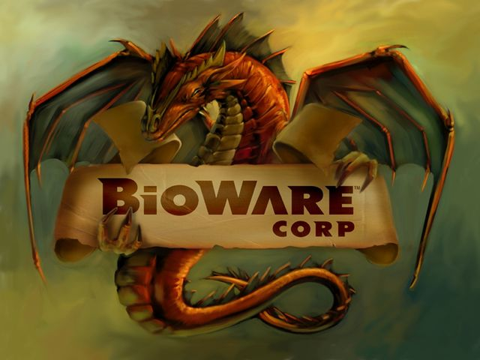Bioware Updates

* Patches announced for Mass Effect Andromeda. Bioware asks for consumer feedback for future patches.
* No new Bioware games currently being shown in Bioware’s newsfeed.